S1. Supplementary Table. BioGeoBEARS model selection AICc values for each of the scenarios tested. Highlighted in grey lowest AICc and the second choice in light grey.
Scenario | Model | LnL | numparams | d | e | j | AICc | AICc_wt
Control | DEC | -102.4 | 2 | 0.014 | 0.0084 | 0 | 209 | 0.34
Control | DEC+J | -100.8 | 3 | 0.0046 | 1.00E-12 | 0.014 | 208.2 | 0.51
Control | DIVALIKE | -103.6 | 2 | 0.0068 | 1.00E-12 | 0 | 211.5 | 0.098
Control | DIVALIKE+J | -103.2 | 3 | 0.0062 | 1.00E-12 | 0.0045 | 213 | 0.047
Control | BAYAREALIKE | -120.4 | 2 | 0.0086 | 0.064 | 0 | 245.1 | 4.90E-09
Control | BAYAREALIKE+J | -111.3 | 3 | 0.0043 | 0.037 | 0.014 | 229.3 | 1.30E-05
Pebas & Acre Systems | DEC | -106 | 2 | 0.014 | 0.0092 | 0 | 216.3 | 0.015
Pebas & Acre Systems | DEC+J | -100.9 | 3 | 0.0055 | 1.00E-12 | 0.016 | 208.4 | 0.78
Pebas & Acre Systems | DIVALIKE | -103.8 | 2 | 0.0083 | 1.00E-12 | 0 | 212 | 0.13
Pebas & Acre Systems | DIVALIKE+J | -103.2 | 3 | 0.0073 | 1.00E-12 | 0.0064 | 213 | 0.076
Pebas & Acre Systems | BAYAREALIKE | -121.2 | 2 | 0.0089 | 0.059 | 0 | 246.7 | 3.60E-09
Pebas & Acre Systems | BAYAREALIKE+J | -111.6 | 3 | 0.0051 | 0.037 | 0.014 | 229.9 | 1.70E-05
Andes | DEC | -103.3 | 2 | 0.016 | 0.0084 | 0 | 211 | 0.54
Andes | DEC+J | -102.6 | 3 | 0.0048 | 1.00E-12 | 0.015 | 211.8 | 0.36
Andes | DIVALIKE | -105.4 | 2 | 0.0072 | 1.00E-12 | 0 | 215.1 | 0.068
Andes | DIVALIKE+J | -104.9 | 3 | 0.0065 | 1.00E-12 | 0.0048 | 216.5 | 0.034
Andes | BAYAREALIKE | -121.1 | 2 | 0.0087 | 0.062 | 0 | 246.5 | 1.00E-08
Andes | BAYAREALIKE+J | -112 | 3 | 0.0044 | 0.038 | 0.014 | 230.6 | 3.00E-05

S2.
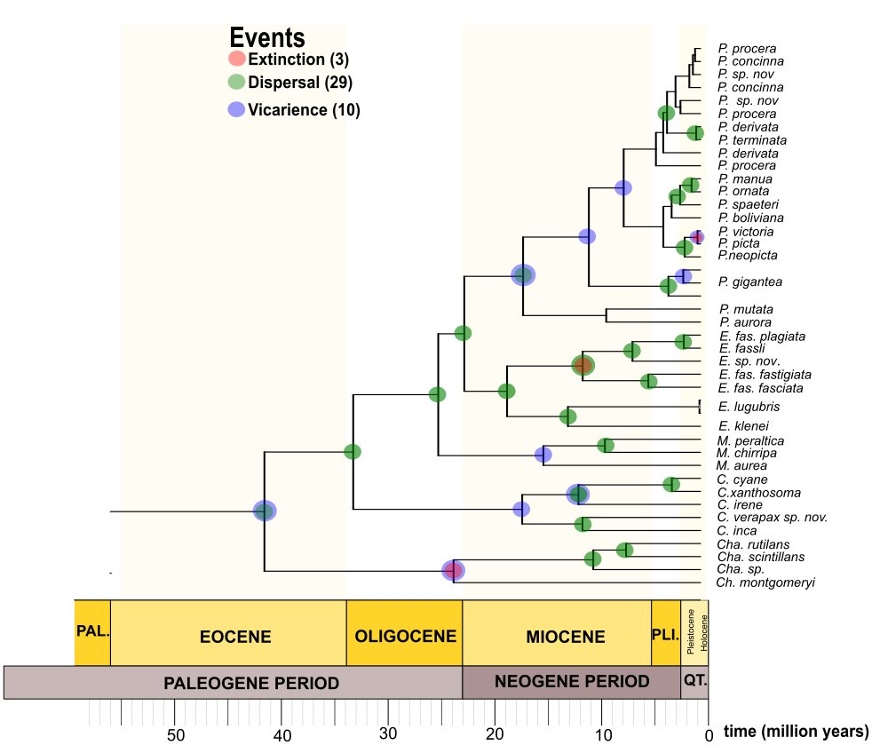

S3.
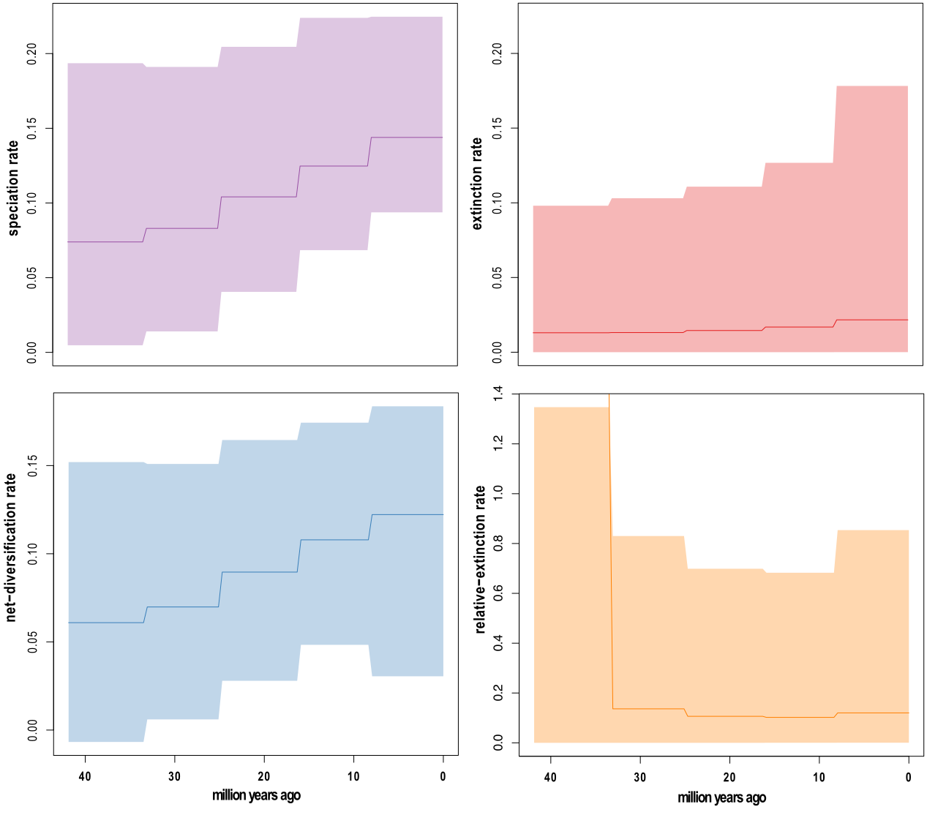

S4.
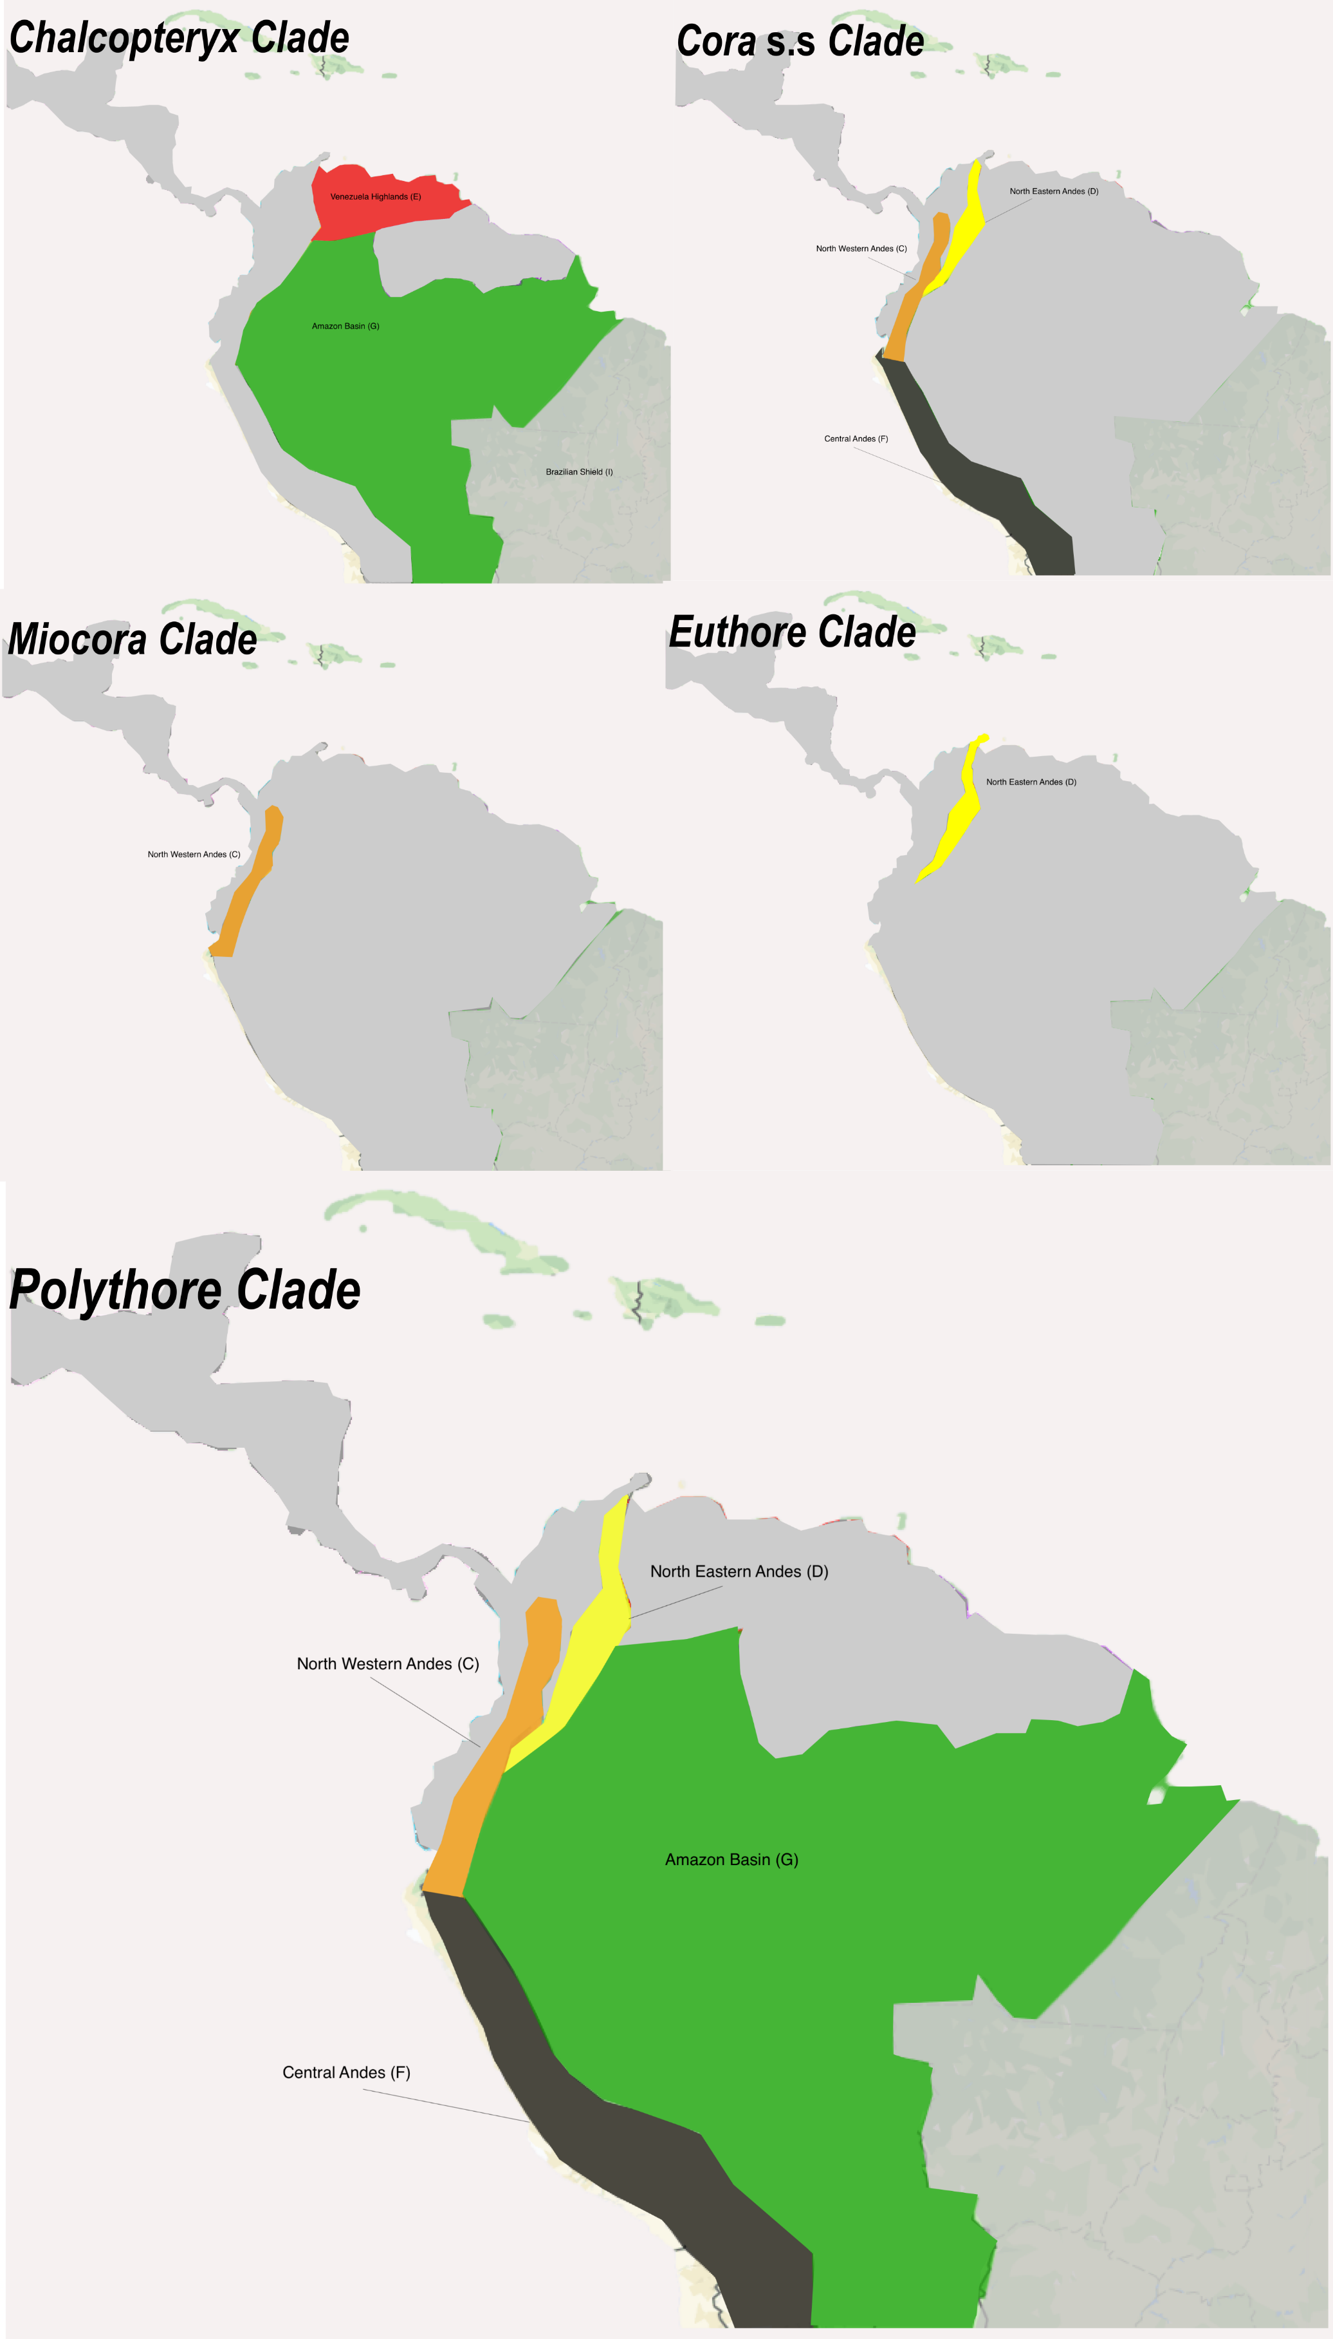

S5.
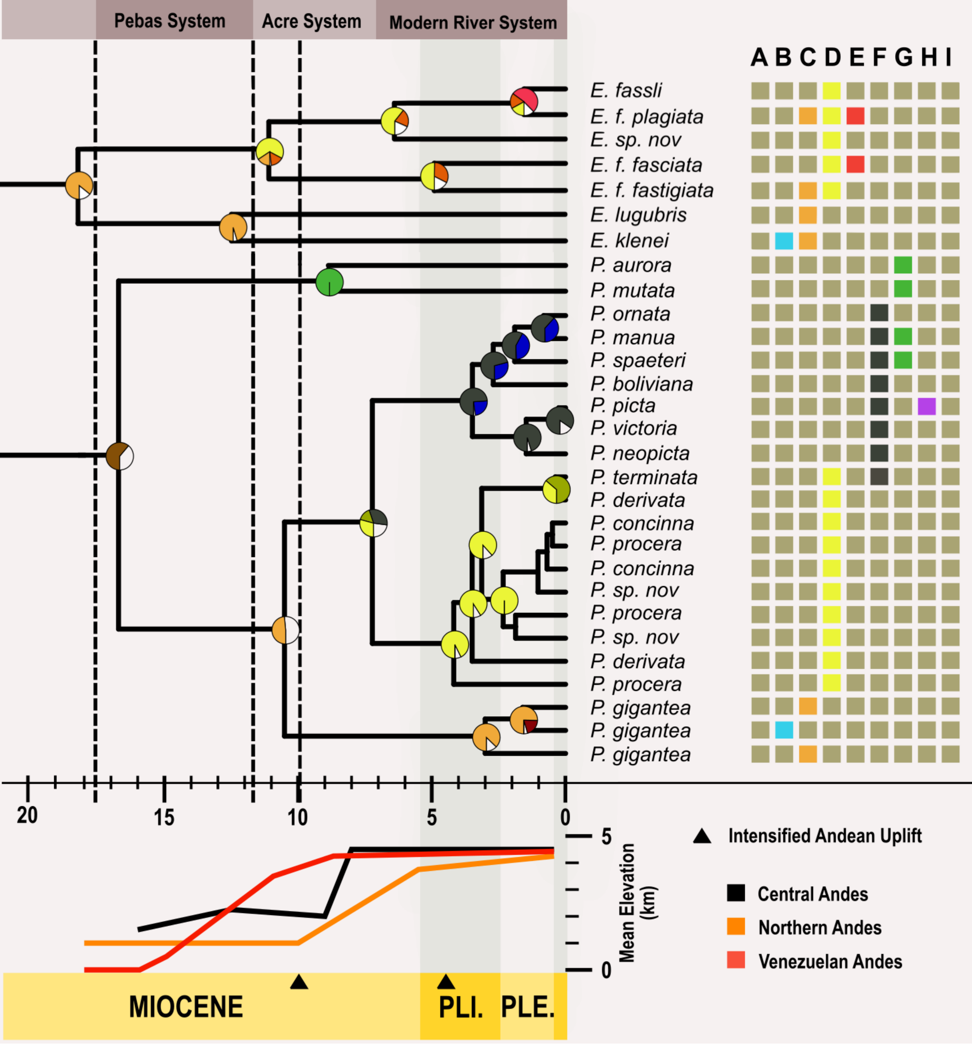

S6.
 |  |  |  | Accesion Numbers
Taxa | Voucher Code | Geographical Origin | Coleccion | COI | ND1 | 16S | 18S | 28S | EF1
Chalcothore montgomery | RG1 | Venezuela | RWG |  |  | MF069482 | MF074095
Chalcopteryx sp. | ChalPeru | Peru, Iquitos | MSH-RU | MF109945
Chalcopteryx rutilans | RMNH505717 |  | GenBank | KF369663 |  |  |  | KF370061
Chalcopteryx scintillans | MIT152 | Colombia, Vaupes, Mitu | MSH-RU | MF109953 |  | MF069477 | MF074089 | MF074108 | MF150179
Cora inca | FSCA138 | Ecuador, Napo, Baeza | FSCA |  | MF109922 | MF069468 | MF074082
 | FSCA140 | Ecuador, Napo, Baeza | FSCA |  | MF109923 | MF069469 | MF074083 | MF074104
Cora irene | FSCA146 | Bolivia, Cochamba, Rio Mayu | FSCA |  | MF109924 | MF069470 | MF074084
Cora cyane | OD173 |  | GenBank | EU055413 |  | EU055124 | EU055217 | EU055315
Cora xanthostoma | BOY03 | Colombia, Cundinamarca, Guayabetal | ANDES | MF109944 | MF109919 | MF069465 | MF074079
Cora verapax | TM63 | Colombia, Risaralda, PNN Tatamá | UAE | In progress | In progress | In progress | In progress
 | MSH161 | Colombia, Cundinamarca, Guayabetal | ANDES | MF109954
Miocora aurea | OD2 | Colombia, Valle del Cauca, Rio Dagua | MSH-RU | MF109958 | MF109931 |  | MF074090 |  | MF150180
 | PY002 | Colombia, Valle del Cauca, Anchicaya | ANDES | MF109964
 | PY001 | Colombia, Valle del Cauca, Anchicaya | ANDES | MF109963
Miocora peraltica | MSH505 | Colombia, Valle del Cauca, Anchicaya | ANDES | MF109957
Miocora chirripa | FSCA380 | Costa Rica, San Jose | FSCA | MF109948
Euthore s.l. klenei | PY003 | Colombia, Valle del Cauca, Anchicaya | ANDES | MF109965
 | COR247 | Ecuador, Imbabura, Reserva los Cedros | MSH-RU | MF109946 |  |  |  |  | MF150175
Euthore s.l. lugubris | UAE19 | Colombia, Antioquia, Jardin, Truchera | UAE | In progress | In progress | In progress | In progress
 | UAE20 | Colombia, Antioquia, Cocorna | UAE | In progress | In progress | In progress | In progress
Euthore fasciata plagiata | UAE15 | Colombia, Huila, El Pital, Vereda el Recreo | UAE | In progress | In progress | In progress | In progress
Euthore fasciata fasciata | BOY02 | Colombia, Cundinamarca, Guayabetal | ANDES |  |  | MF069464 | MF074078
 | OD174 |  | GenBank | EU055414 |  | EU055125 | EU055218 | EU055316
 | MSH162 | Colombia, Cundinamarca, Guayabetal | ANDES | MF109955
Euthore fasciata fastigiata | MSH501 | Venezuela, Tachira | ANDES |  | MF109930
Euthore fassli | UAE1 | Colombia, Antioquia, Jardin, Vereda La Floresta | UAE | In progress | In progress | In progress | In progress
Polythore aurora | IQ | Peru, Iquitos | MSH-RU | KP738290 |  | MF069474 |  | MF074106
Polythore mutata | TIP | Ecuador, Orellana, Tiputini Biological Station | MSH-RU | MF109971 | MF109942 | MF069492 | MF074102 | MF074112
Polythore gigantea | FSCA733 | Ecuador, Cotopaxi, Las Pampas | FSCA |  |  | MF069471
 | A | Colombia, Antioquia, Sabaneta | MSH-RU | MF109943 | MF109917 | MF069463 | MF074077 | MF074103
 | MIN | Ecuador, Imbabura, Reserva los Cedros | MSH-RU | MF109952 | MF109928 | MF069476 | MF074088 | MF074107 | MF10177
Polythore manua | UAE35 | Peru, Madre de Dios, Reserva Patiacolla | UAE | In progress | In progress | In progress | In progress
Polythore picta | FSCA940 |  | FSCA | MF109949
Polythore victoria | STAC | Peru, Pasco, Pozuzo, Rio Santa Cruz | MSH-RU | MF109969 | MF109940 | MF069490 | MF074100
Polythore neopicta | POZ | Peru, Pasco, Pozuzo | MSH-RU | MF109962 | MF109935 | MF069481 | MF074092 | MF074110
Polythore ornata | PH | Peru, Junin, Pampa Hermosa | MSH-RU | MF109961 | MF109934 | MF069480 | MF074092 | MF074109
Polythore boliviana | OD182 |  | GenBank |  |  | EU055131 | EU055225 | EU055323
Polythore spaeteri | PAN | Peru, Panguana Biological Station | MSH-RU | MF109960 | MF109933 | MF069479 | MF074092
Polythore derivata | OD5 | Colombia, Caqueta, Florencia | MSH-RU | MF109959
 | TAR | Peru, San Martin, Tarapoto | MSH-RU | MF109970 | MF109941 | MF069491 | MF074101 | MF074111 | MF150181
Polythore procera | RN | Ecuador, Tungurahagua, Rio Negro | MSH-RU | MF109967 | MF109939 | MF069488
 | G | Colombia, Cundinamarca, Guayabetal | MSH-RU | FJ514995 | MF109925 | MF069472 | MF074085 | MF074105 | MF150176
 | CH | Colombia, Cundinamarca, Chirajara | MSH-RU | FJ514997 | MF109920 | MF069466 | MF074080 |  | MF150174
Polythore terminata | H | Ecuador, Napo, Tena, Rio Hollin | MSH-RU |  | MF109926 | MF069473 | MF074086
Polythore concinna | L | Ecuador, Napo, Loreto | MSH-RU | MF109951 | MF109927 | MF069475 | MF074087
 | PA | Ecuador, Napo, Puerto Ahuana | MSH-RU |  | MF109932 | MF069478 | MF074091
Polythore sp. nov | SAN | Colombia, Huila, San Agustin | MSH-RU | MF109968 |  | MF069489
 | F | Colombia, Caqueta, Florencia | MSH-RU | MF109947 | MF109921 | MF069467 | MF074081
Pseudolestes mirabilis | RG3 |  | RWG |  |  | MF069483
Bayderi | RG4 |  | RWG |  |  | MF069484 | MF074096
Archineura | RG5 |  | RWG |  |  | MF069485 | MF074097
Euphaea | RG6 |  | RWG |  |  | MF069486 | MF074098 |  | MF150178
Diaphlebia | RG8 |  | RWG
Philoganga vetusa | RG9 |  | RWG | MF109966 |  | MF069487
Euphaea formosa | EfRa010 | Fongkang River, Taiwan | GenBank | HM126547 | HM126547 | HM126547

S7.
Gene | Primers |  | Annealing Temperature (C) | Reference
Cytochrome oxidase subunit 1 | CJ-2195 | TTG ATT TTT TGG TCA TCC AGA AGT | 48 - 52 | Simon et al. 1994
 | TL2-N-3014 | TCC AAT GCA CTA ATC TGC CAT ATT A
NADH Dehydrogenase | P850 | TTC AAA CCG GTG TAA GCC AGG | 49 - 52 | Simon et al. 1994
 | P851 | TAG AAT TAG AAG ATC AAC CAG
16S mt ribosomal subunit | 16SF | TTA CGC TGT TAT CCC TAA | 48 - 49 | Simon et al. 1994
 | 16SAR | CGC CTG TTT ATC AAA AAC AT
18S n ribosomal subunit | 18SF | TAC CTG GTT GAT CCT GCC AGT AG | 48 - 49 | Simon et al. 1994
 | 18SB | TAA CCG CAA CAA CTT TAA T
28S n ribosomal subunit | 28SA | GAC CCG TCT TGA AGC ACG | 48 - 49 | Simon et al. 1994
 | 28SB | TCG GAA GGA ACC AGC TAC
Elongation factor alpha I | EF1-F-2361 | YGGMCACAGRGATTTCATCAA | 49 - 52 | Simon et al. 1994
 | EF1-R-3093 | CCAGGRTGGTTRAGCACRATGA
Simon, C., Frati, F., Beckenbach, A., Crespi, B., Liu, H. & Flook, P. (1994) Evolution, Weighting, and Phylogenetic Utility of Mitochondrial Gene Sequences and a Compilation of Conserved Polymerase Chain Reaction Primers. Annals of the Entomological Society of America, 87, 651-701.

S8. Supplementary Appendix. Details on the model parameters, areas allowed, dispersal probabilities and time stratification schemes for each Control, Pebas&Acre System and Andes.

Control Scenario
Hypothesis (NULL): The geological history of South America did not play an important role in the dispersal and diversification of the family Polythoridae.

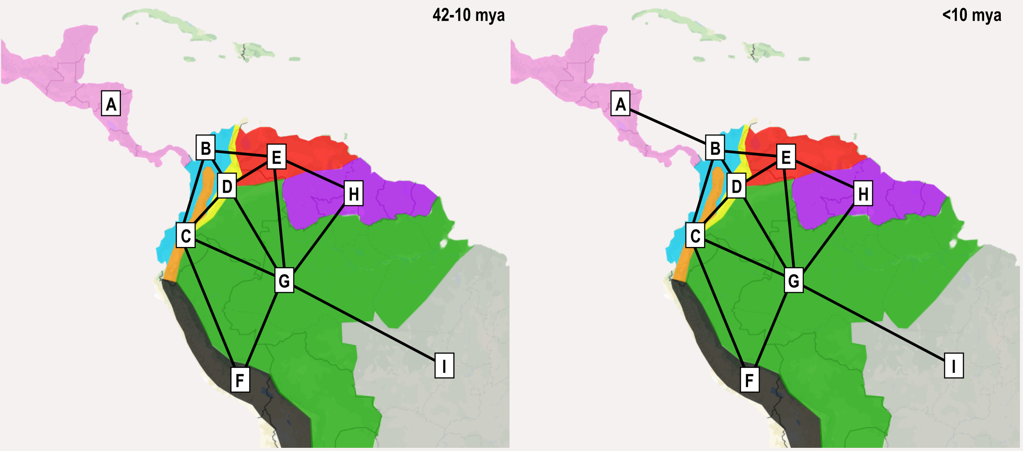
Areas Allowed: Yes (removed impossible from areas adjacency)
Dispersal probabilities: Yes (but all were set to 1)
D and E were free, non J and J models were run.
Time Stratified analysis: Yes, but only accounts for the Isthmus of Panama.

Pebas and Acre Systems Scenario
Hypothesis (A): The geological history of South America did play a crucial role in the dispersal and diversification of the family Polythoridae.
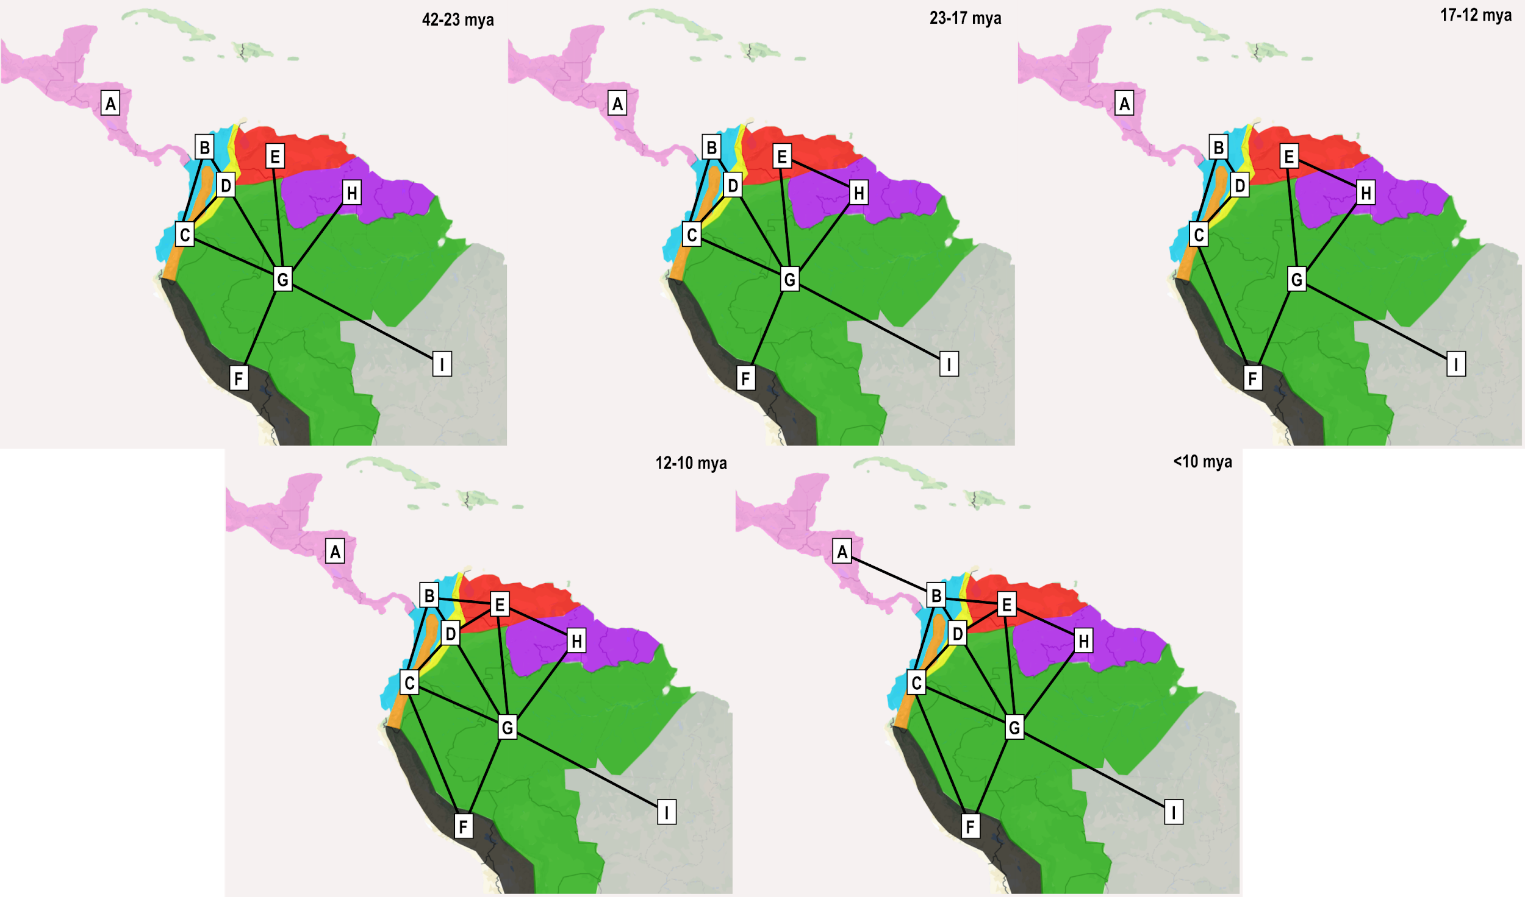
Coded:
Areas Allowed: Yes (removed impossible from areas adjacency, and geological history (Pebas, Acre)
Dispersal probabilities: Yes (but all were set to 1)
D and E were free, non J and J models were run.
Time Stratified analysis: Yes, accounts for the Isthmus of Panama, marine incursions, and Pebas/Acre wetland systems.

Andes Scenario.
Hypothesis: The gradual uplift of the Andean range, combined with the geological history of South America, played a crucial role in the dispersal and diversification of the family Polythoridae.

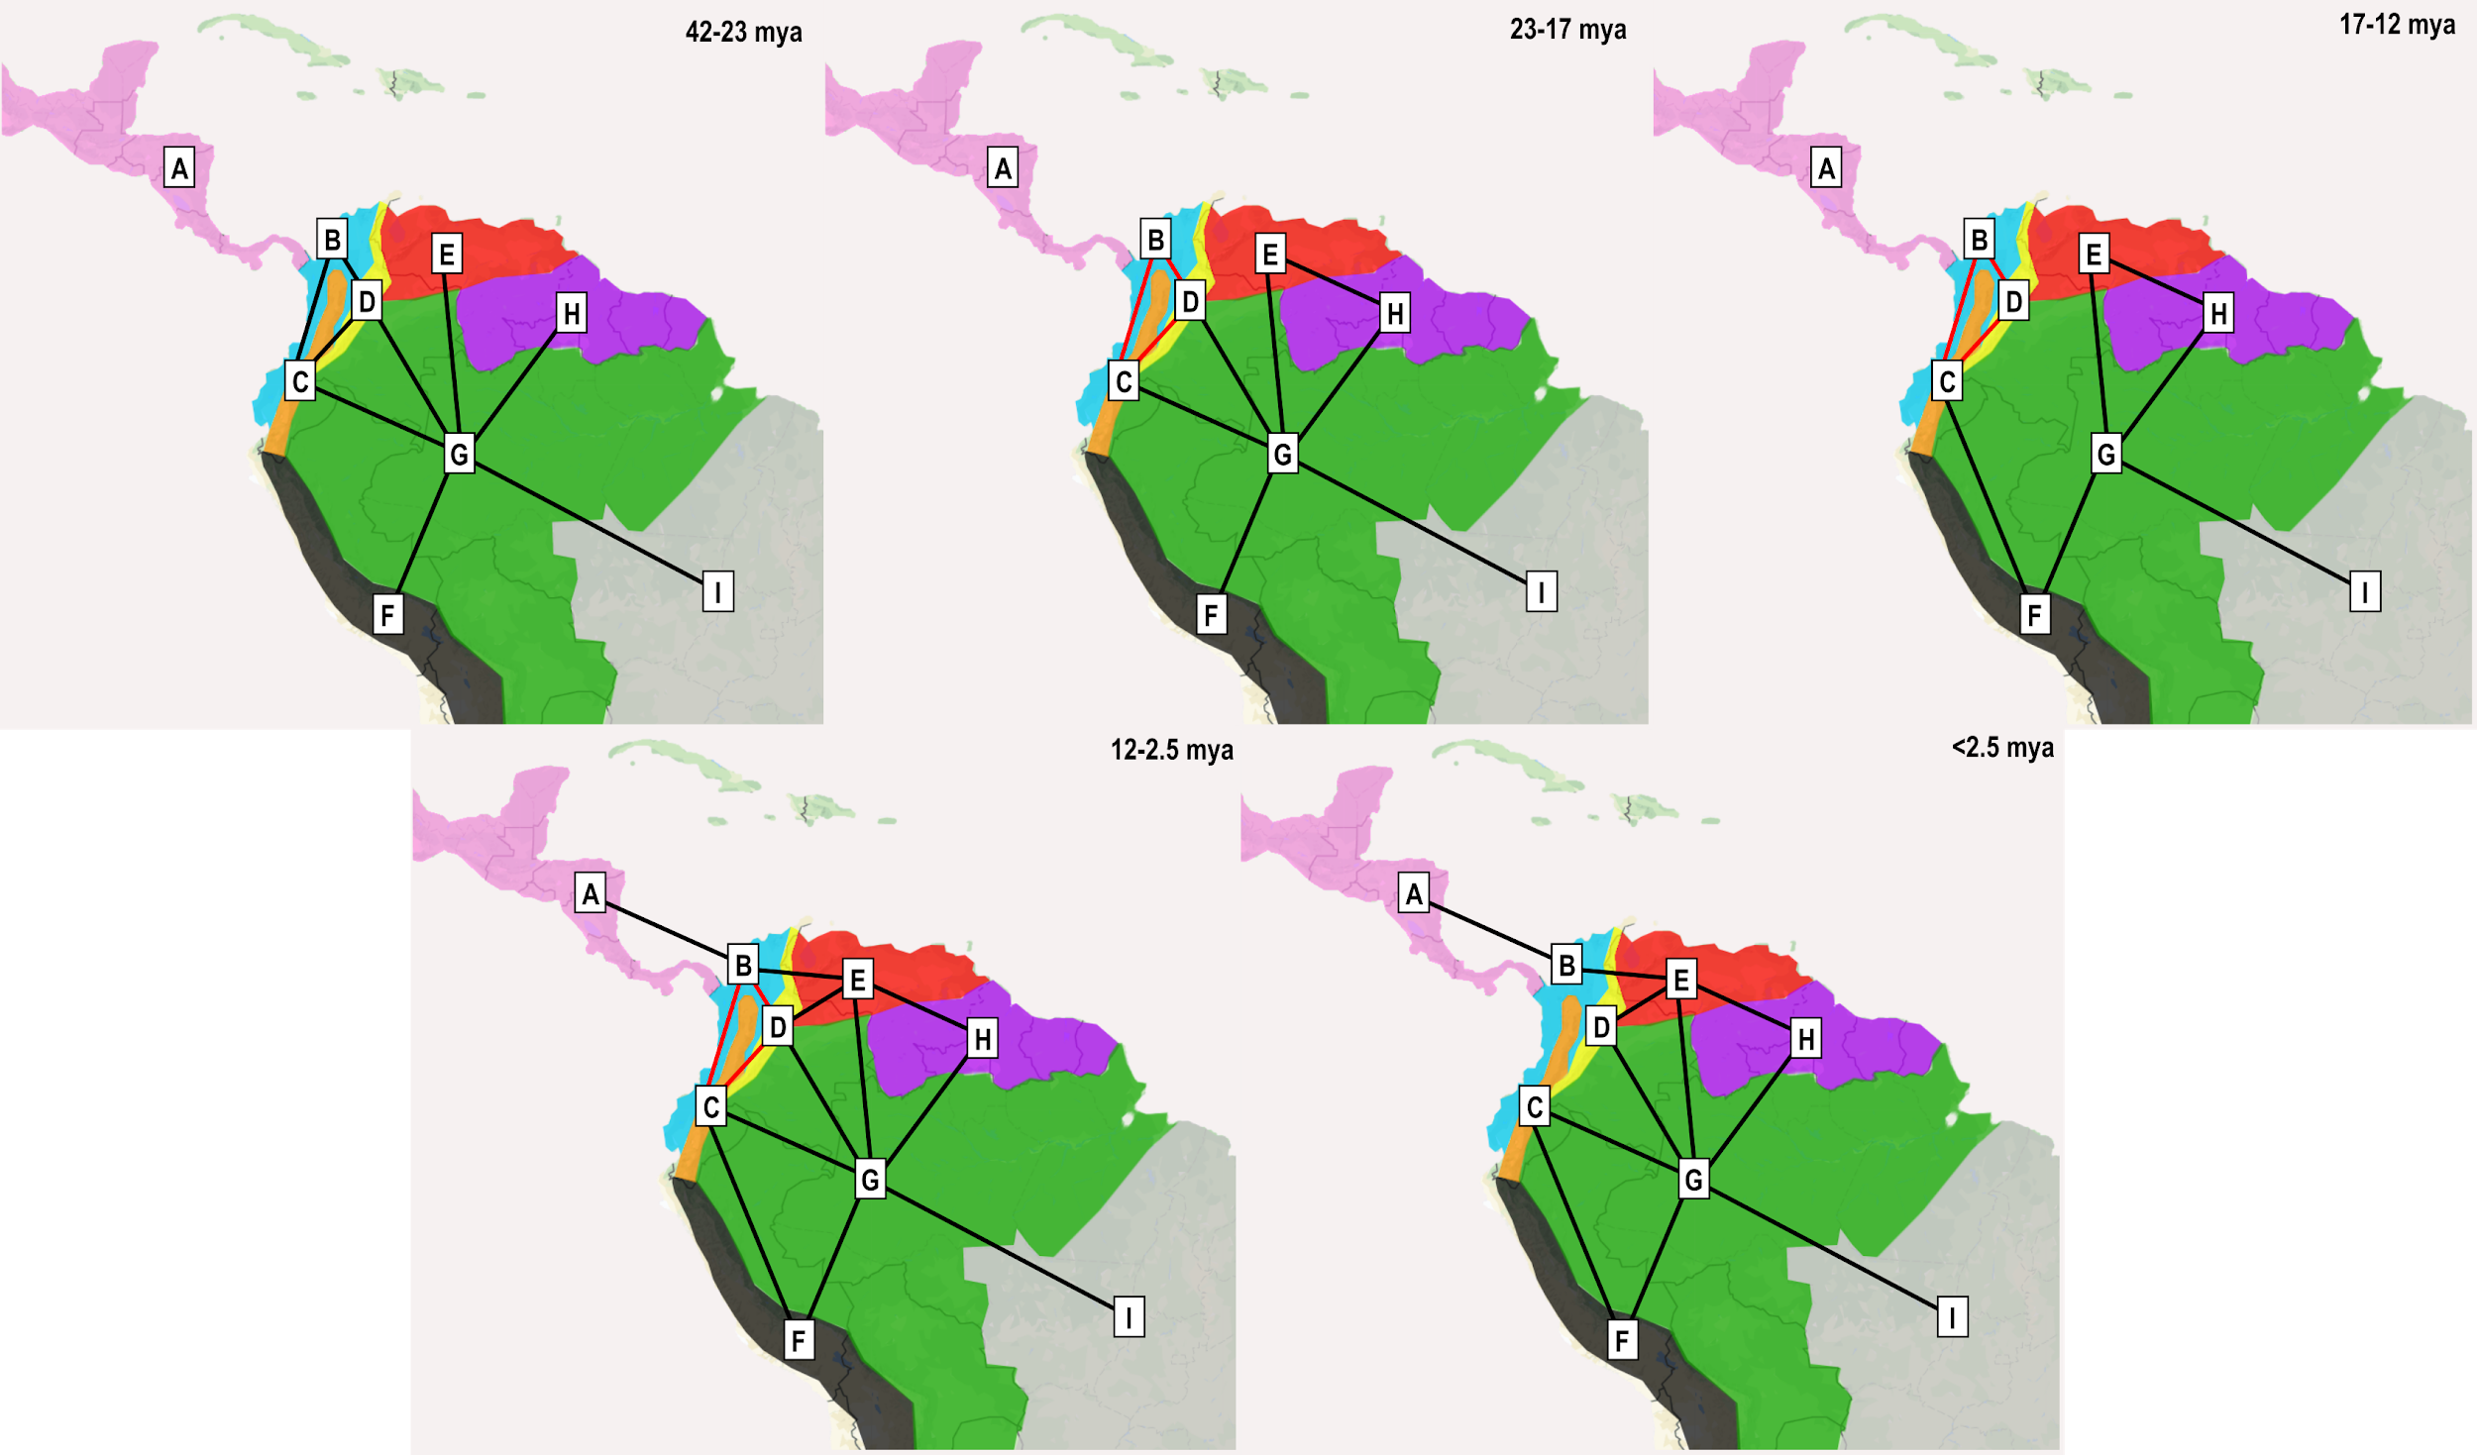
Coded:
Areas Allowed: Yes (removed impossible from areas adjacency, and geological history (Pebas, Acre)
Dispersal probabilities: Yes (Areas with increased Andean uplight had decreased dispersal probabilities)
D and E were free, non J and J models were run.
Time Stratified analysis: Yes, accounts for the Isthmus of Panama, marine incursions, and Pebas/Acre wetland systems, uplift of Andes restricting dispersal.

